ISM 4403 Homework Week 4

### Tasks:

Create a new Excel spreadsheet from the following table.

|  |  |  |  |  |  |
| --- | --- | --- | --- | --- | --- |
| id | Height (inches) | gender | Hair color | Eye Color | Age |
| 1 | 67 | male | brown | brown | 25 |
| 2 | 64 | female | brown | green | 23 |
| 3 | 74 | male | blond | blue | 27 |
| 4 | 73 | Male | brown | brown | 35 |
| 5 | 60 | female | red | green | 40 |
| 6 | 61 | female | brown | green | 45 |
| 7 | 73 | female | blond | blue | 41 |
| 8 | 70 | female | brown | blue | 50 |
| 9 | 56 | female | blond | brown | 60 |
| 10 | 57 | male | blond | brown | 18 |

Import the the sheet into R. **check**

Calculate the following.

The mean height. **check**

The sum of all heights. **check**

The mode for gender, hair color, and eye color. **.5**

Plot a pie graph for each of the following parameters, gender (count), hair color (count), eye color (count). **check**

Plot a line graph of height and age. In your opinion is there a relationship between height and age? Please explain why or why not. **check**

**Paste your code here**

# importing data also taking care of nas

dataset = read.csv('lab4_flat_file.csv')

head(dataset)

#install.packages("dplyr")

#install.packages("tidyverse")

#install.packages("modeest")

#load dplyr

library(dplyr)

library(caret)

library(modeest)

# encoding the dataset

names(dataset) <- c("id", "height", "gender", "hair_color", "eye_color", "age")

gender_num <- factor(dataset$gender, level = c("female", "male"), labels =c(1,2))

hair_color_num <- factor(dataset$hair_color, level = c("brown", "blond", "red"), labels =c(1,2,3))

eye_color_num <- factor(dataset$eye_color, level = c("brown", "green", "blue"), labels =c(1,2,3))

head(dataset)

# summary of data

mean(dataset$height)

sum(dataset$height)

# trying to get mode

getMode <- function(x) {

keys <- unique(x)

keys[which.max(tabulate(match(x, keys)))]

}

# I got the mode formula from https://www.tutorialspoint.com/r/r_mean_median_mode.htm

gendermode <- getMode(gender_num)

print(gendermode)

hairmode <- getMode(hair_color_num)

print(hairmode)

eyemode <- getMode(eye_num)

print(eyemode)

# summary of data

summary(dataset)

count_gender <- table(dataset$gender)

count_hair <- table(dataset$hair_color)

count_eye <- table(dataset$eye_color)

## pie and line chart

count(dataset$gender)

pie(count_gender)

pie(count_hair)

pie(count_eye)

# line chart

plot(y = dataset$height , x = dataset$age, type = "l",

title(main = "Realtionship Between Height & Age",

xlab = "Age", ylab = "Height"))

# no there is no relationship between height and age. All the people in this dataset are <20 years old.

# meaning there is no connection between the two.

**End of Paste**

**Paste your results here**

> # importing data also taking care of nas

> dataset = read.csv('lab4_flat_file.csv')

Error in file(file, "rt") : cannot open the connection

In addition: Warning message:

In file(file, "rt") :

cannot open file 'lab4_flat_file.csv': No such file or directory

> head(dataset)

Error in head(dataset) : object 'dataset' not found

> #install.packages("dplyr")

> #install.packages("tidyverse")

> #install.packages("modeest")

> #load dplyr

> library(dplyr)

Attaching package: ‘dplyr’

The following objects are masked from ‘package:xts’:

first, last

The following objects are masked from ‘package:stats’:

filter, lag

The following objects are masked from ‘package:base’:

intersect, setdiff, setequal, union

Warning message:

package ‘dplyr’ was built under R version 3.6.2

> library(caret)

Loading required package: lattice

Loading required package: ggplot2

Warning message:

package ‘caret’ was built under R version 3.6.2

> library(modeest)

Warning message:

package ‘modeest’ was built under R version 3.6.2

>

> # encoding the dataset

> names(dataset) <- c("id", "height", "gender", "hair_color", "eye_color", "age")

Error in names(dataset) <- c("id", "height", "gender", "hair_color", "eye_color", :

object 'dataset' not found

> gender_num <- factor(dataset$gender, level = c("female", "male"), labels =c(1,2))

Error in factor(dataset$gender, level = c("female", "male"), labels = c(1, :

object 'dataset' not found

> hair_color_num <- factor(dataset$hair_color, level = c("brown", "blond", "red"), labels =c(1,2,3))

Error in factor(dataset$hair_color, level = c("brown", "blond", "red"), :

object 'dataset' not found

> eye_color_num <- factor(dataset$eye_color, level = c("brown", "green", "blue"), labels =c(1,2,3))

Error in factor(dataset$eye_color, level = c("brown", "green", "blue"), :

object 'dataset' not found

> head(dataset)

Error in head(dataset) : object 'dataset' not found

>

> # summary of data

> mean(dataset$height)

Error in mean(dataset$height) : object 'dataset' not found

> sum(dataset$height)

Error: object 'dataset' not found

> # trying to get mode

> getMode <- function(x) {

+ keys <- unique(x)

+ keys[which.max(tabulate(match(x, keys)))]

+ }

>

> # I got the mode formula from https://www.tutorialspoint.com/r/r_mean_median_mode.htm

>

> gendermode <- getMode(gender_num)

Error in unique(x) : object 'gender_num' not found

> print(gendermode)

Error in print(gendermode) : object 'gendermode' not found

>

> hairmode <- getMode(hair_color_num)

Error in unique(x) : object 'hair_color_num' not found

> print(hairmode)

Error in print(hairmode) : object 'hairmode' not found

>

> eyemode <- getMode(eye_num)

Error in unique(x) : object 'eye_num' not found

> print(eyemode)

Error in print(eyemode) : object 'eyemode' not found

>

>

> # summary of data

>

> summary(dataset)

Error in summary(dataset) : object 'dataset' not found

> count_gender <- table(dataset$gender)

Error in table(dataset$gender) : object 'dataset' not found

> count_hair <- table(dataset$hair_color)

Error in table(dataset$hair_color) : object 'dataset' not found

> count_eye <- table(dataset$eye_color)

Error in table(dataset$eye_color) : object 'dataset' not found

>

>

> ## pie and line chart

> count(dataset$gender)

Error in group_vars(x) : object 'dataset' not found

>

> pie(count_gender)

Error in pie(count_gender) : object 'count_gender' not found

> pie(count_hair)

Error in pie(count_hair) : object 'count_hair' not found

> pie(count_eye)

Error in pie(count_eye) : object 'count_eye' not found

>

> # line chart

>

> plot(y = dataset$height , x = dataset$age, type = "l",

+ title(main = "Realtionship Between Height & Age",

+ xlab = "Age", ylab = "Height"))

Error in plot(y = dataset$height, x = dataset$age, type = "l", title(main = "Realtionship Between Height & Age", :

object 'dataset' not found

> # no there is no relationship between height and age. All the people in this dataset are <20 years old.

> # meaning there is not connetion between the two.

**End of Paste**

Is there a relationship between height and age? Please explain? # no there is no relationship between height and age. All the people in this dataset are <20 years old.

# meaning there is no connection between the two.

**Paste your answer here**

**## part 2 quantmod**

**#install.packages("quantmod")**

**library("quantmod")**

**# apple stock AAPL**

**getSymbols("AAPL", src = "yahoo")**

**addMACD()**

**addBBands()**

**# boeing stock BA**

**getSymbols("BA", src = "yahoo")**

**# nvida stock**

**getSymbols("NVDA", src = "yahoo")**

**# AMD stock**

**getSymbols("AMD", src = "yahoo")**

**# intel stock**

**getSymbols("INTC", src = "yahoo")**

**# apple stock AAPL**

**getSymbols("AAPL", src = "yahoo")**

**# use chart series**

**addMACD()**

**addBBands()**

**mean_apple <- mean(AAPL$AAPL.Close)**

**mean_amd <- mean(AMD$AMD.Close)**

**mean_ba <- mean(BA$BA.Close)**

**mean_intc <- mean(INTC$INTC.Close)**

**df2 <- data.frame(mean_apple, mean_amd, mean_ba, mean_intc)**

**# you need this make the df a matrix before you can plot the data**

**df2 = as.matrix(df2)**

**merge(mean_apple, mean_amd, mean_ba, mean_intc, all = TRUE)**

**barplot(df2, main = "Mean Closing Price",**

**xlab = "Stock Ticker", ylab = "Price in USD", las = 1)**

**End of Page**

Using the Quantmod interface get data for Boeing, Apple, Nvida, AMD, and Intel. (See the following for more information <https://github.com/joshuaulrich/quantmod>) Yahoo finance should be used as your source.

Print the mean stock price for each stock

Chart it in a Bar chart

**Paste your resulting code here**

## part 2 quantmod

>

> #install.packages("quantmod")

> library("quantmod")

>

> # apple stock AAPL

> getSymbols("AAPL", src = "yahoo")

[1] "AAPL"

Warning message:

'indexClass<-' is deprecated.

Use 'tclass<-' instead.

See help("Deprecated") and help("xts-deprecated").

> addMACD()

Error in get.current.chob() : improperly set or missing graphics device

> addBBands()

Error in get.current.chob() : improperly set or missing graphics device

> # boeing stock BA

> getSymbols("BA", src = "yahoo")

[1] "BA"

Warning message:

'indexClass<-' is deprecated.

Use 'tclass<-' instead.

See help("Deprecated") and help("xts-deprecated").

> # nvida stock

> getSymbols("NVDA", src = "yahoo")

[1] "NVDA"

Warning message:

'indexClass<-' is deprecated.

Use 'tclass<-' instead.

See help("Deprecated") and help("xts-deprecated").

> # AMD stock

> getSymbols("AMD", src = "yahoo")

[1] "AMD"

Warning message:

'indexClass<-' is deprecated.

Use 'tclass<-' instead.

See help("Deprecated") and help("xts-deprecated").

> # intel stock

> getSymbols("INTC", src = "yahoo")

[1] "INTC"

Warning message:

'indexClass<-' is deprecated.

Use 'tclass<-' instead.

See help("Deprecated") and help("xts-deprecated").

>

> # apple stock AAPL

> getSymbols("AAPL", src = "yahoo")

[1] "AAPL"

Warning message:

'indexClass<-' is deprecated.

Use 'tclass<-' instead.

See help("Deprecated") and help("xts-deprecated").

> # use chart series

> addMACD()

Error in get.current.chob() : improperly set or missing graphics device

> addBBands()

Error in get.current.chob() : improperly set or missing graphics device

>

> mean_apple <- mean(AAPL$AAPL.Close)

> mean_amd <- mean(AMD$AMD.Close)

> mean_ba <- mean(BA$BA.Close)

> mean_intc <- mean(INTC$INTC.Close)

> df2 <- data.frame(mean_apple, mean_amd, mean_ba, mean_intc)

> # you need this make the df a matrix before you can plot the data

> df2 = as.matrix(df2)

> merge(mean_apple, mean_amd, mean_ba, mean_intc, all = TRUE)

Error in fix.by(by.x, x) : 'by' must match numbers of columns

>

> barplot(df2, main = "Mean Closing Price",

+ xlab = "Stock Ticker", ylab = "Price in USD", las = 1)

**END OF Paste**

**Paste your resulting graph here**

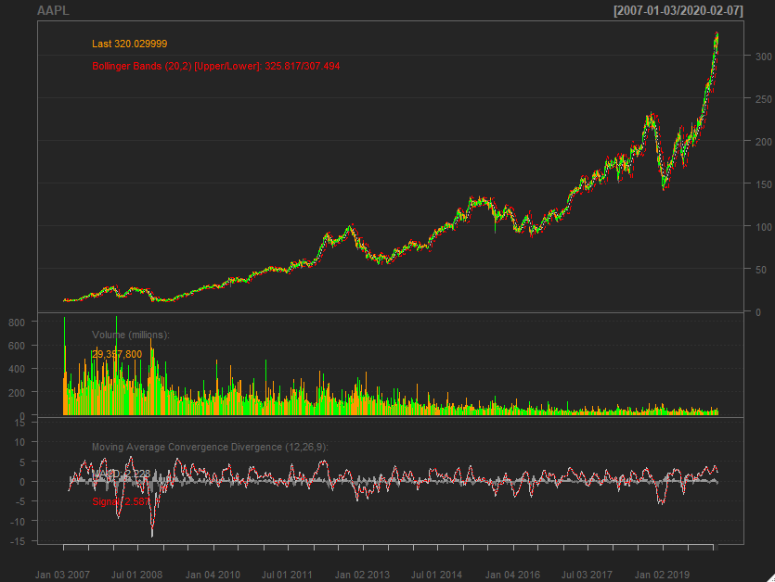

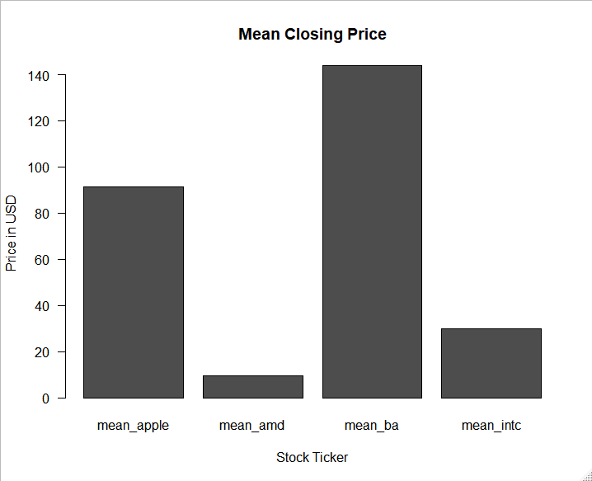

**END of Paste**

**Rubric:**

35 points for pasting correct summary charts.

15 points for determining if there is a relationship in the data.

15 For connecting to the GDI system by installing the module.

35 for generating a Graph from the Quantmod system.